Name: Anuranan Goswami

Reg No: 20BKT0093

Week 1 Assignment

Q: Create, Update and Delete Commands in MongoDB as well as MySQL. Create tables and perform join operation.

**CODE:**

MySQL

**CREATE TABLE CUSTOMERS(**

**CUSTOMER_ID INT PRIMARY KEY, /*primary key*/**

**CUSTOMER_NAME VARCHAR(40),**

**CONTACT_NAME VARCHAR(40)**

**);**

**CREATE TABLE ORDERS(**

**ORDER_ID INT PRIMARY KEY, /*primary key*/**

**CUSTOMER_ID INT,**

**FOREIGN KEY(CUSTOMER_ID) REFERENCES CUSTOMERS(CUSTOMER_ID),**

**ORDER_DATE DATE /*date data type*/**

**);**

**INSERT INTO CUSTOMERS VALUES(1, 'Anuj Srivastav', 'Anuj');**

**INSERT INTO CUSTOMERS VALUES(2, 'Vishal Sharma', 'Vishal');**

**INSERT INTO CUSTOMERS VALUES(3, 'Anuranan Goswami', 'Ran');**

**INSERT INTO ORDERS VALUES(10308, 2, '1996-09-18');**

**INSERT INTO ORDERS VALUES(10309, 1, '1996-09-19');**

**INSERT INTO ORDERS VALUES(10310, 3, '1996-09-20');**

**SELECT * FROM CUSTOMERS;**

**SELECT * FROM ORDERS;**

**SELECT ORDERS.ORDER_ID, CUSTOMERS.CUSTOMER_NAME, ORDERS.ORDER_DATE**

**FROM ORDERS**

**INNER JOIN CUSTOMERS ON ORDERS.CUSTOMER_ID=CUSTOMERS.CUSTOMER_ID;**

**SELECT ORDERS.ORDER_ID, CUSTOMERS.CUSTOMER_NAME, ORDERS.ORDER_DATE**

**FROM ORDERS**

**LEFT JOIN CUSTOMERS ON ORDERS.CUSTOMER_ID=CUSTOMERS.CUSTOMER_ID;**

**SELECT ORDERS.ORDER_ID, CUSTOMERS.CUSTOMER_NAME, ORDERS.ORDER_DATE**

**FROM ORDERS**

**RIGHT JOIN CUSTOMERS ON ORDERS.CUSTOMER_ID=CUSTOMERS.CUSTOMER_ID;**

**SELECT ORDERS.ORDER_ID, CUSTOMERS.CUSTOMER_NAME, ORDERS.ORDER_DATE**

**FROM ORDERS**

**OUTER JOIN CUSTOMERS ON ORDERS.CUSTOMER_ID=CUSTOMERS.CUSTOMER_ID;**

**CREATE TABLE Patients**

**(**

**ID int(6) NOT NULL PRIMARY KEY,**

**NAME varchar(40),**

**ADDRESS varchar(20),**

**AGE INT DEFAULT(18)**

**);**

**INSERT INTO PATIENTS VALUES(1, 'Anuranan', 'Vellore', 28);**

**INSERT INTO PATIENTS VALUES(2, 'Manoj', 'Kolkata', 56);**

**INSERT INTO PATIENTS VALUES(3, 'Dipika', 'Delhi', 45);**

**INSERT INTO PATIENTS VALUES(4, 'Amit', 'Delhi');**

**SELECT * FROM PATIENTS;**

**DROP TABLE PATIENTS;**

Output:

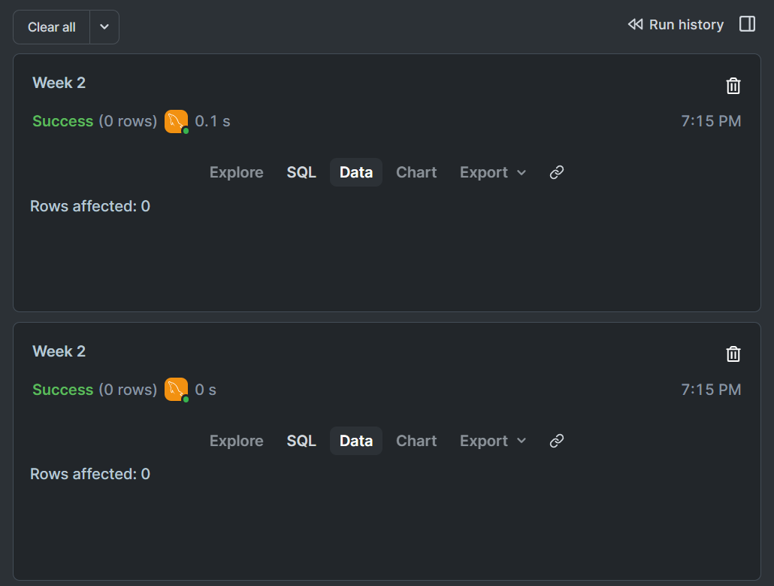

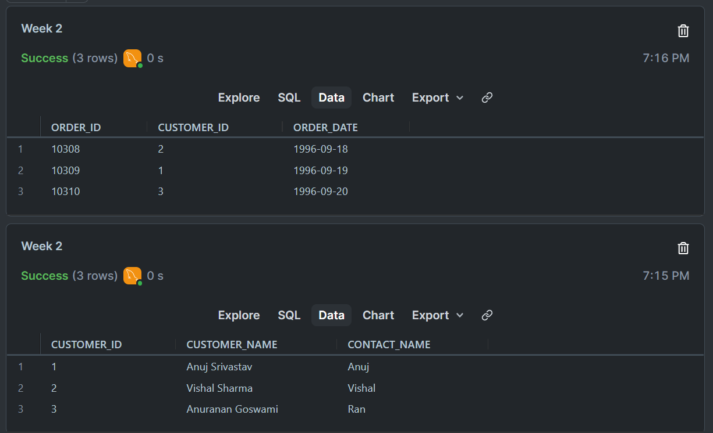

MongoDB:

Create:

// Insert a single document

db.collectionName.insertOne({ key1: value1, key2: value2 });

// Insert multiple documents

db.collectionName.insertMany([

{ key1: value1, key2: value2 },

{ key1: value3, key2: value4 }

]);

Read:

// Find all documents in a collection

db.collectionName.find();

// Find documents that match specific criteria

db.collectionName.find({ key: value });

// Find documents and limit the result

db.collectionName.find().limit(5);

// Find documents and sort the result

db.collectionName.find().sort({ key: 1 }); // 1 for ascending, -1 for descending

Update:

// Update a single document

db.collectionName.updateOne(

{ key: value }, // Filter criteria

{ $set: { newKey: newValue } } // Update operation

);

// Update multiple documents

db.collectionName.updateMany(

{ key: value }, // Filter criteria

{ $set: { newKey: newValue } } // Update operation

);

Delete:

// Delete a single document

db.collectionName.deleteOne({ key: value });

// Delete multiple documents

db.collectionName.deleteMany({ key: value });